ABSTRACT
IoT enabled robot for detecting gas pipe leakage

An IoT enabled robot for detecting gas pipe leakage travels on top of gas pipes and the processing unit (1) receives input from the gas sensor (7) and the temperature and humidity sensor (8) to detect gas leaks. The imaging device (5) is used to provide visual inspection and the torch (6) provides illumination in low-light conditions. The ultrasonic sensor (2) detects the proximity of obstacles, ensuring the robot avoids collisions with them. The processing unit (1) tracks the location and sends alerts to the monitoring and control center (11) if gas leakages are detected.
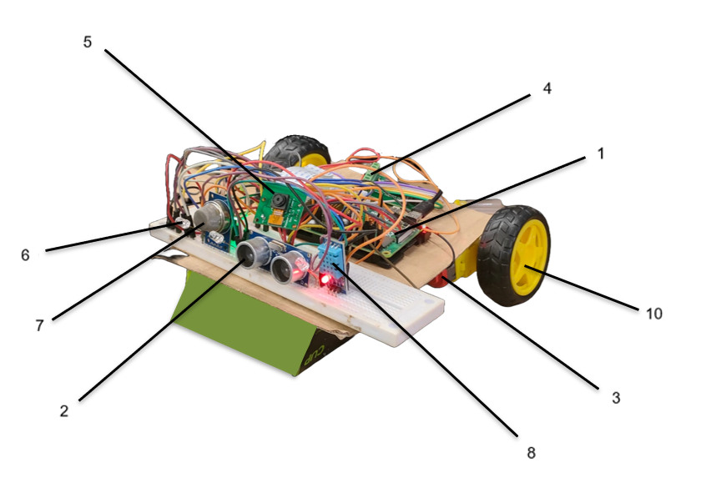
Figure 1

SVKM’s Dwarkadas J. Sanghvi College of Engineering
Applicant

